**Theory**

<https://medium.com/@pushkarmandot/what-is-the-significance-of-c-value-in-support-vector-machine-28224e852c5a>

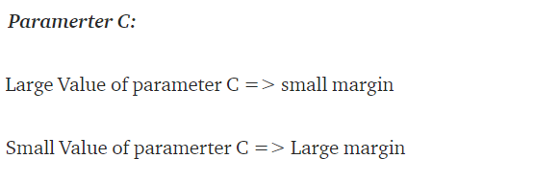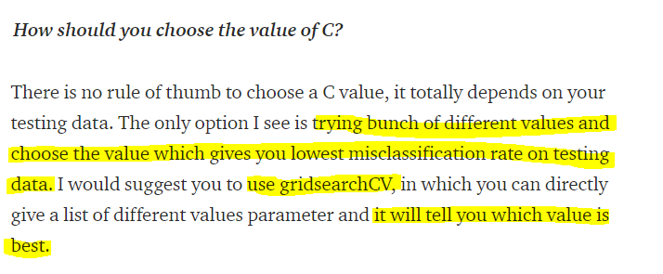

<https://medium.com/@xmauryvrockx/how-to-check-for-linear-separability-13c177ae5a6e>

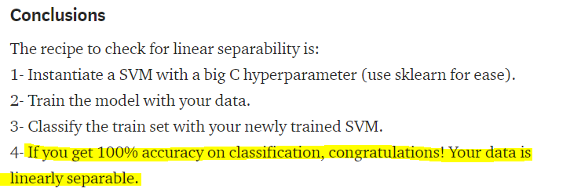

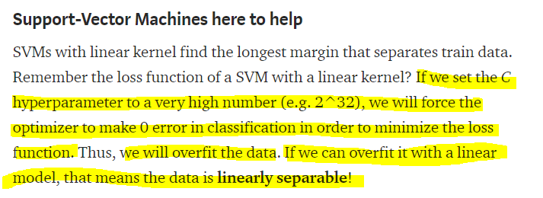

**Conceptual Understanding**

|  |
| --- |
| -Large C Value means lower misclassification rate  -Smaller C Value means higher classification rate  -If we are overtraining the linear model on a small margin then that means that the data was originally linearly seperable to begin with |

**Analysis1- Checking to see if setting a high value for C produces an accuracy of 1.0 which indicates a linearly seperable dataset**

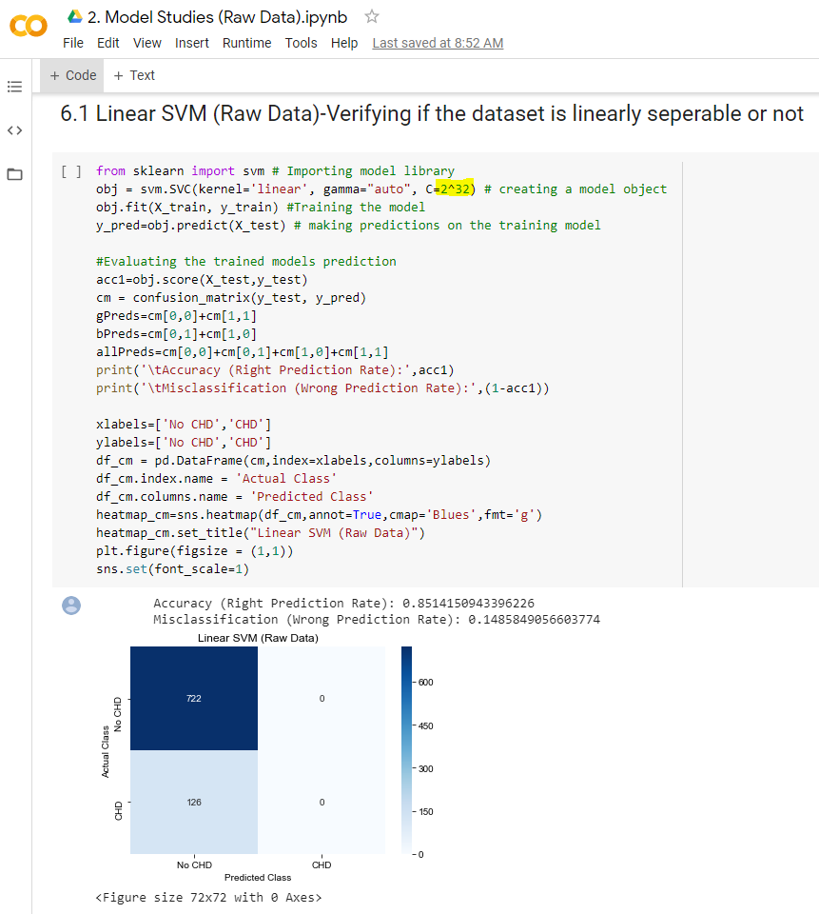

We didn’t get an accuracy of 1.0 when the C value was high so therefore, we know that our dataset is non linearly seperable.

Hypothesis: Dataset is non linearly seperable so its best modeled by SVM Kernels (RBF or Poly)

**Analysis2- Using GridSearch CV in order to find the best kernel for our dataset**

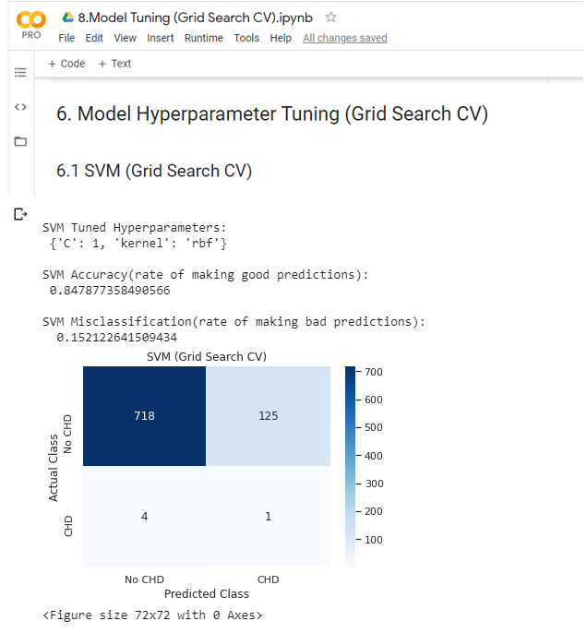

Based on the Grid Search CV we approve our hypothesis listed above.

**Conclusion**

We know with certainty that SVM(Linear) does not fit our dataset well. We know with certainty that SVM(RBF) fits our data set well. We are uncertain about SVM (poly) fitting our dataset better than SVM(RBF) due to computational difficulties.